# RISC-V Compiler and Simulator Setup Tutorial

## Prerequisites

* Computer running Windows 10/11, macOS, or Linux
* Internet connection
* Administrative privileges

## Step 1: Install Cursor

1. Download Cursor: <https://cursor.com/downloads>
2. Install and launch Cursor.
3. Install the following extensions inside Cursor by clicking “extension” icon as shown below. This will open marketplace and just type following:
   * “Remote” and install “Dev Containers” package

## Step 2: Install Git and Clone the Repository

1. Download Git: <https://git-scm.com/downloads>
2. Install Git following the instructions for your OS.
3. Open terminal in Cursor and Verify installation:

* git –-version

1. Clone the project repository:

* git clone <https://github.com/harshdabhi/riscv_project>
* A computer screen with white text

  Description automatically generated

1. Navigate to the code folder:

* cd riscv_project/code
* 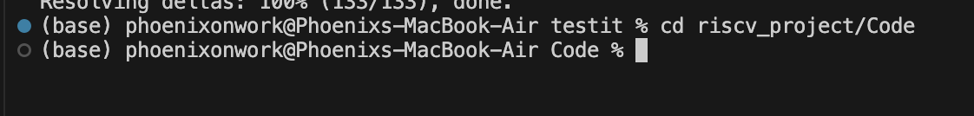

## 

## Step 3: Install Docker

1. Download Docker Desktop: <https://www.docker.com/products/docker-desktop>
2. Install Docker and ensure it is running.
3. Verify installation:
   * docker –version

## Step 4: Set Up the RISC-V Environment using Docker

### Option 1: Build Docker Image (~1 hour)

1. Open terminal in Cursor.
2. Navigate to folder containing Dockerfile.
3. Build the Docker image:

* docker build -t riscv_simulator:latest .

### Option 2: Pull Pre-Built Docker Image

1. Pull the image:

* docker pull phoenix67/finalyear_project:v2

1. Run the container and mount your code folder :

* docker run -it -v $(pwd):/app phoenix67/finalyear_project:v2

## Step 5: Use Cursor Remote Development

1. Open Cursor.
2. On left hand side click on the icon shown in image and toggle to dev containers
3. Click on the arrow button pointing on right side. This will open overall simulator in present folder ( opening will take 2-3 min approx. )

## Step 6: Validate Installation

1. Make the validation script executable:

* chmod +x test_exec.sh

1. Run the script:

* ./test_exec.sh

If you see this message everything has been installed perfectly and running. It also show available cpu and qemu version.

1. Script checks:
   * RISC-V toolchain installation
   * QEMU simulator installation
   * Available tool versions

Success message confirms proper installation.

1. Similarly you can produce overall project results by following this steps

* Make the validation script executable:

chmod +x aes_exec.sh

chmod +x sha_exec.sh

* Run the script:

./aes_exec.sh

./sha_exec.sh

1. For visualization just click on visualization.ipynb notebook

* Click on “Run all” button

## Step 7: Start Developing

* Write RISC-V assembly or C programs
* Compile with riscv64-unknown-elf-gcc ( support both 32 and 64 bit )
* Simulate using QEMU
* Debug using Cursor

## Step 8: Terminate session

* 1. Locate and click on blue color bar in bottom left of cursor terminal
  2. Click on it to get the menu option
  3. Click on last option to terminate the session. This will shutdown the docker container and its session.

